**Department of Computer Engineering**



**Cairo University**

**Faculty of Engineering**

**ELC 325B – Spring 2023**

**Digital Communications**

**Assignment #2**

**Matched filter**

**Submitted to**

Dr. Mai

Dr.Hala

Eng.Khaled Hesham

**Submitted by**

|  |  |  |
| --- | --- | --- |
| **Name** | **Sec** | **BN** |
| **Aya Ahmed Musad Husein** | **1** | **15** |
| **Salma Ragab Hassan** | **1** | **31** |

Contents

**Part 1:…………** 4

**Part 2:…………** 7

Figures

Figure 1 Fig 18

Figure 2 fig 19

Figure 3 Fig 19

Figure 4 Fig 20

Figure 5 Fig 20

# **Part 1:**

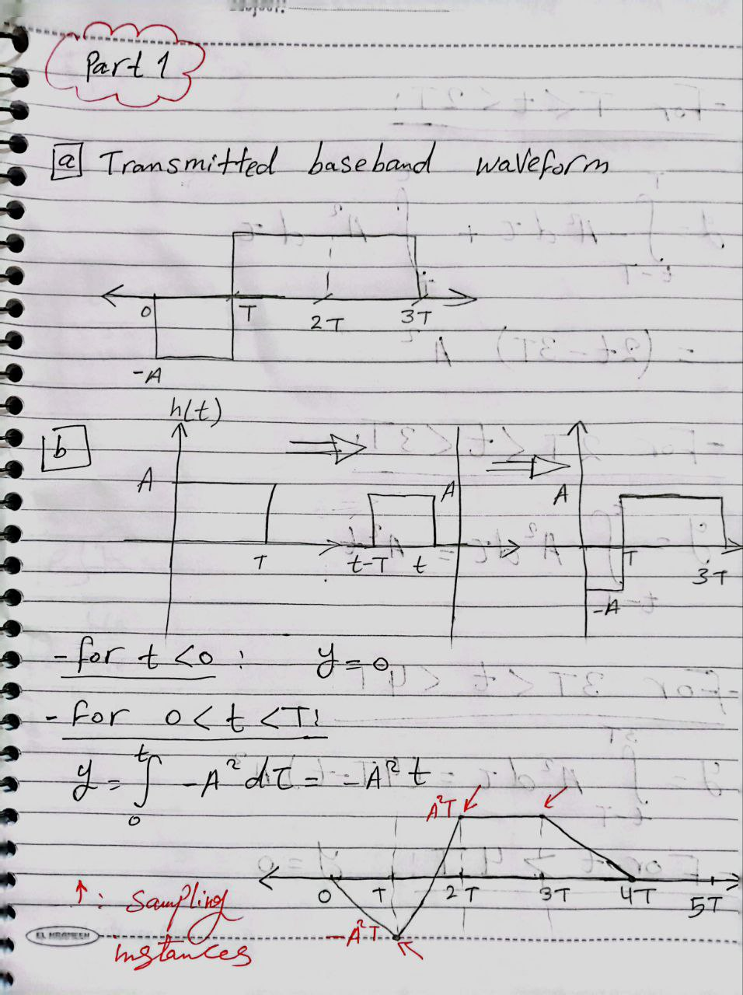

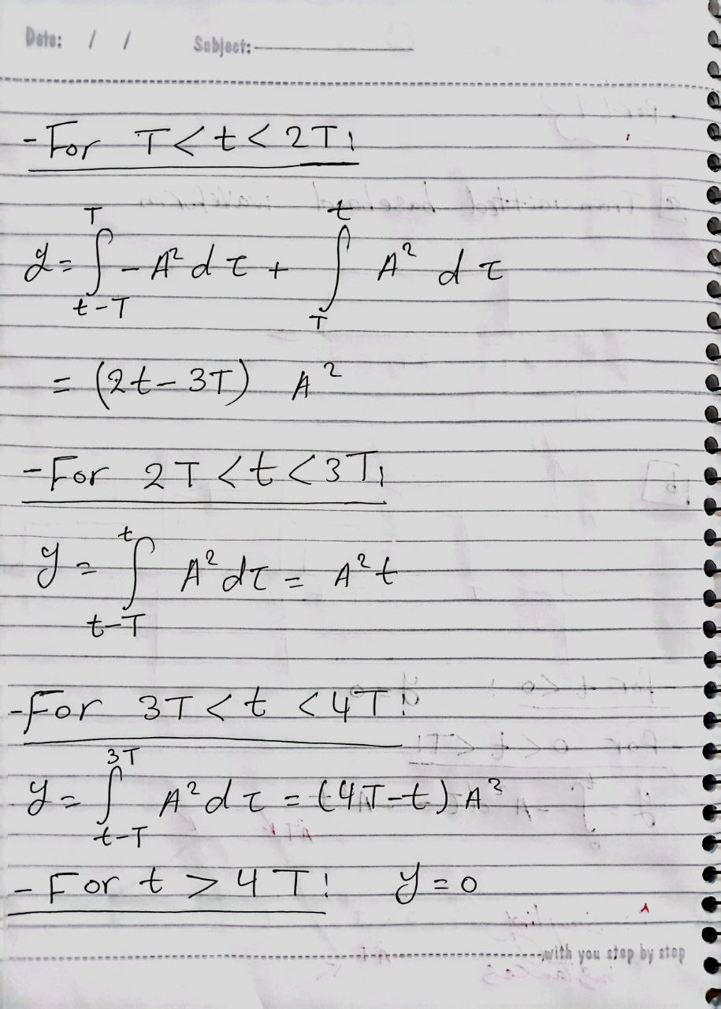

# **Part 2:**

Derivation

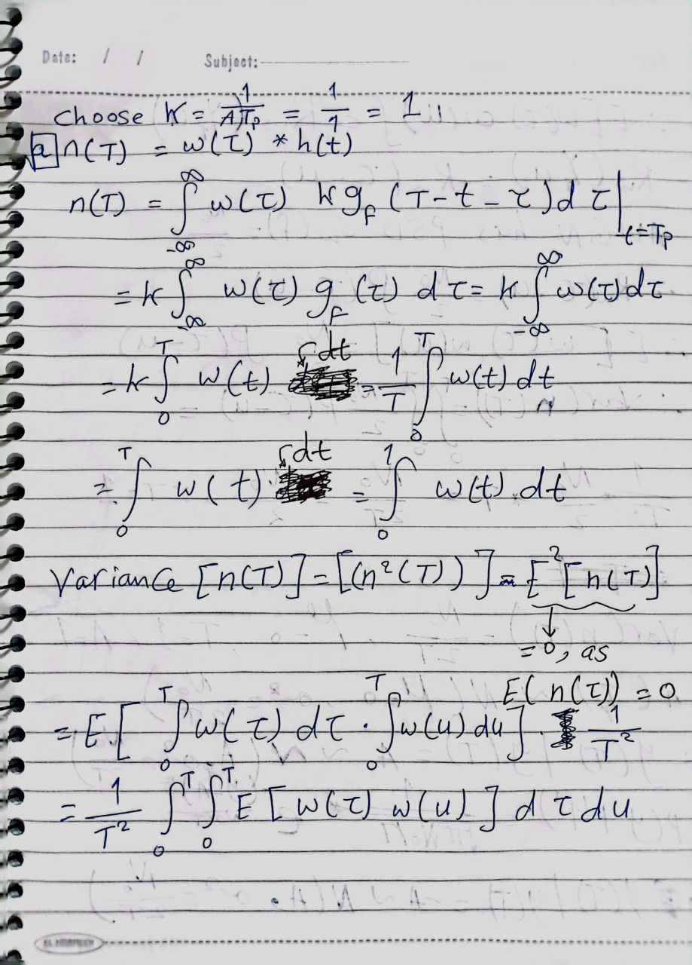

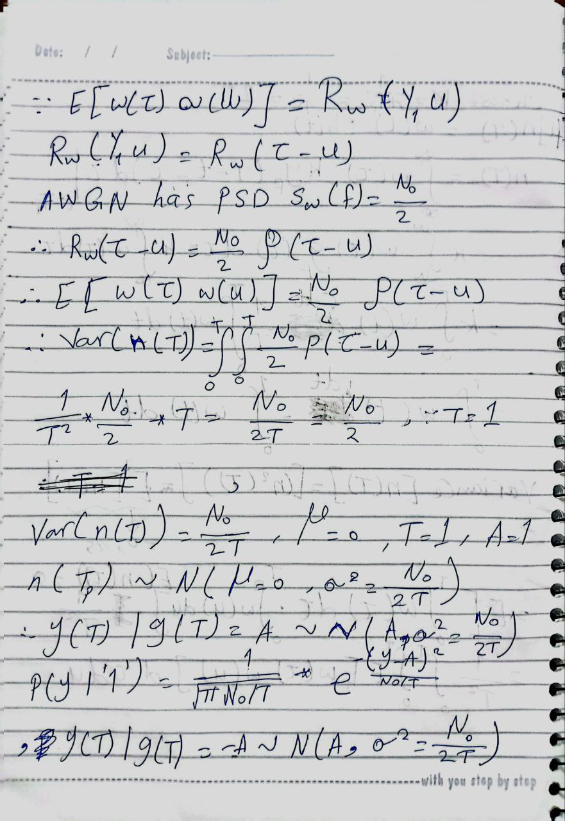

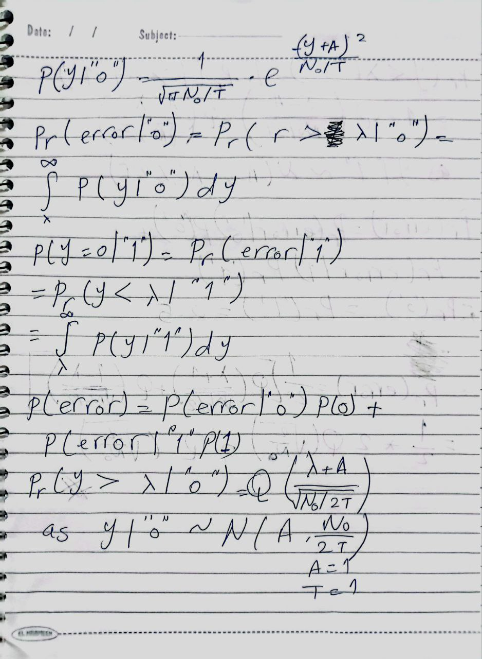

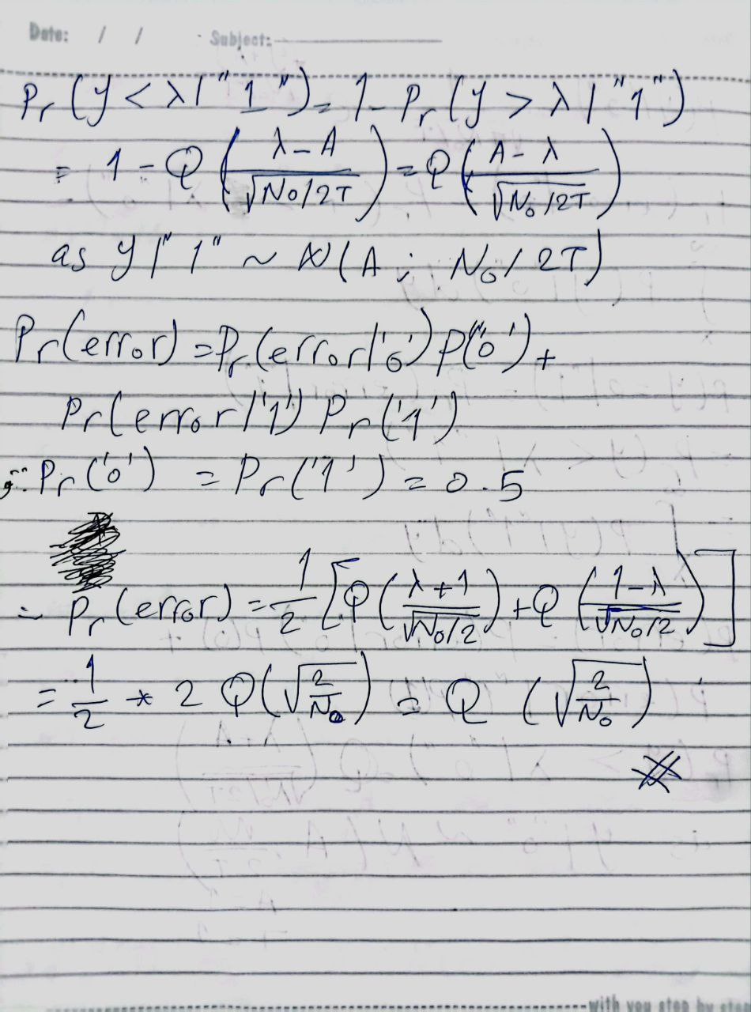

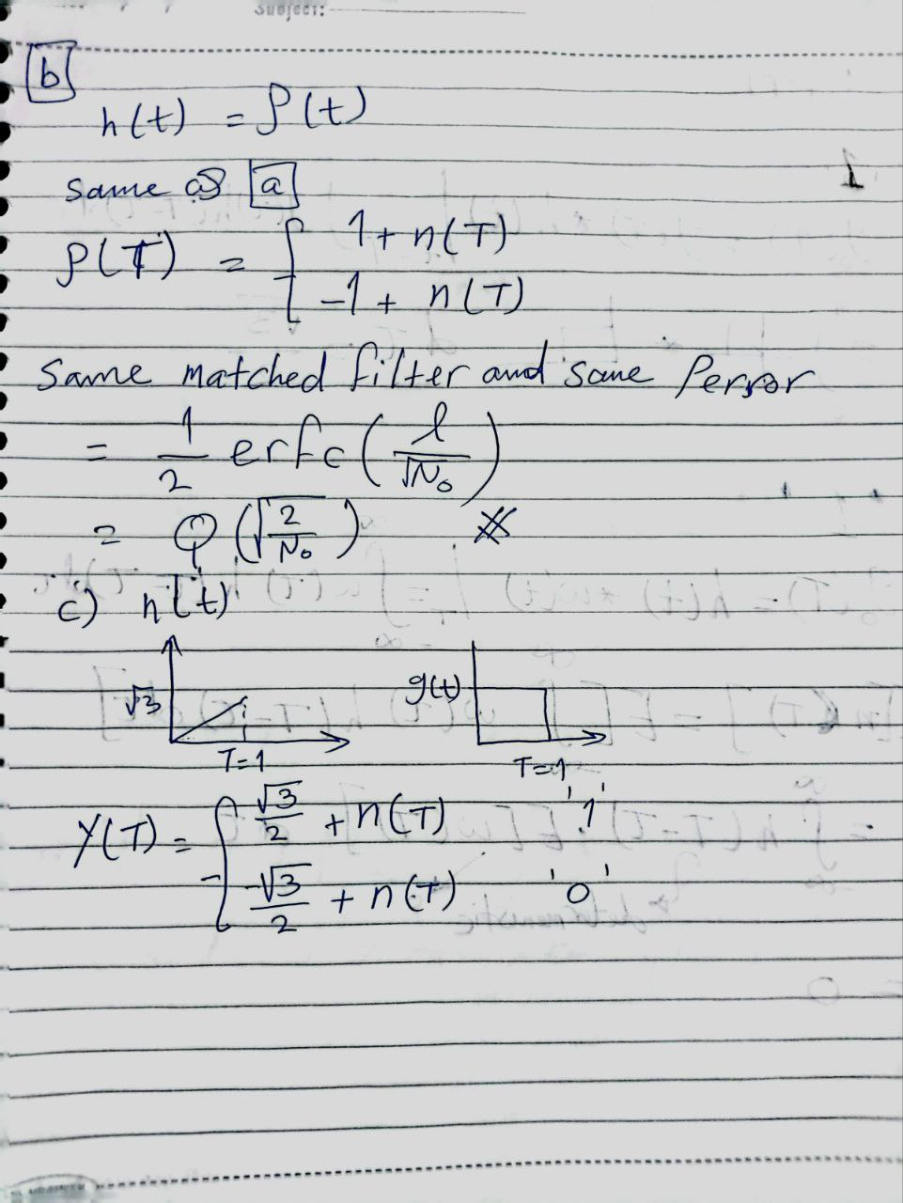

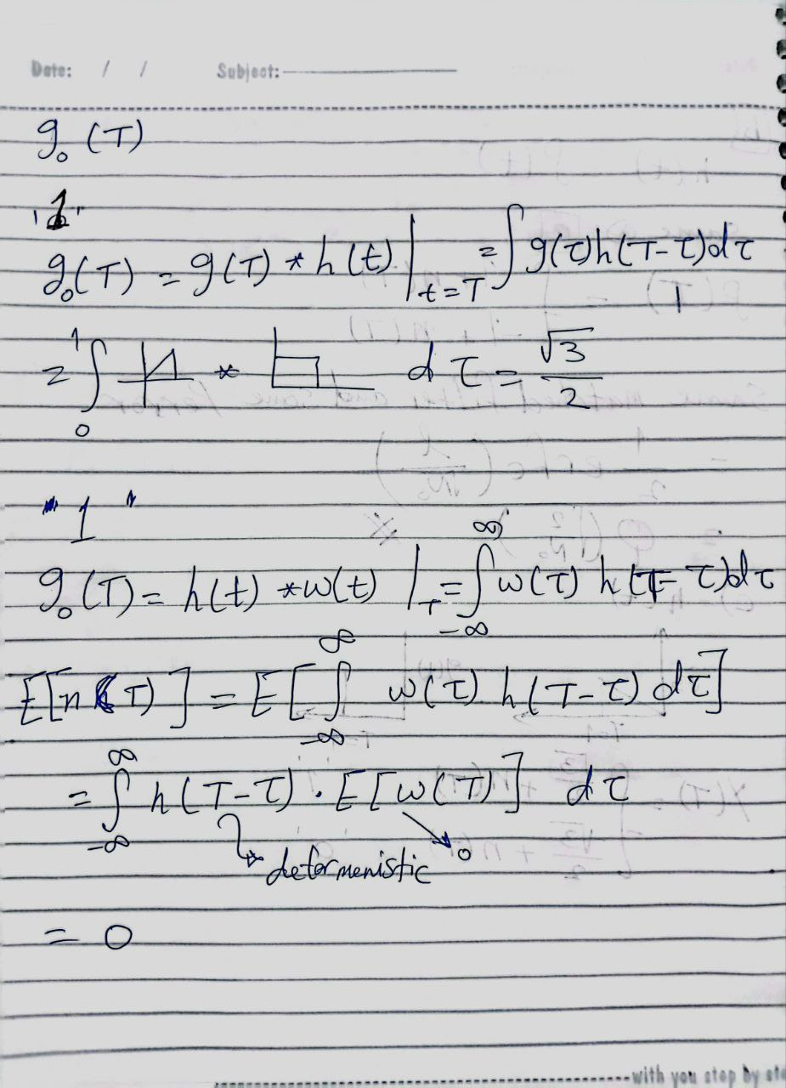

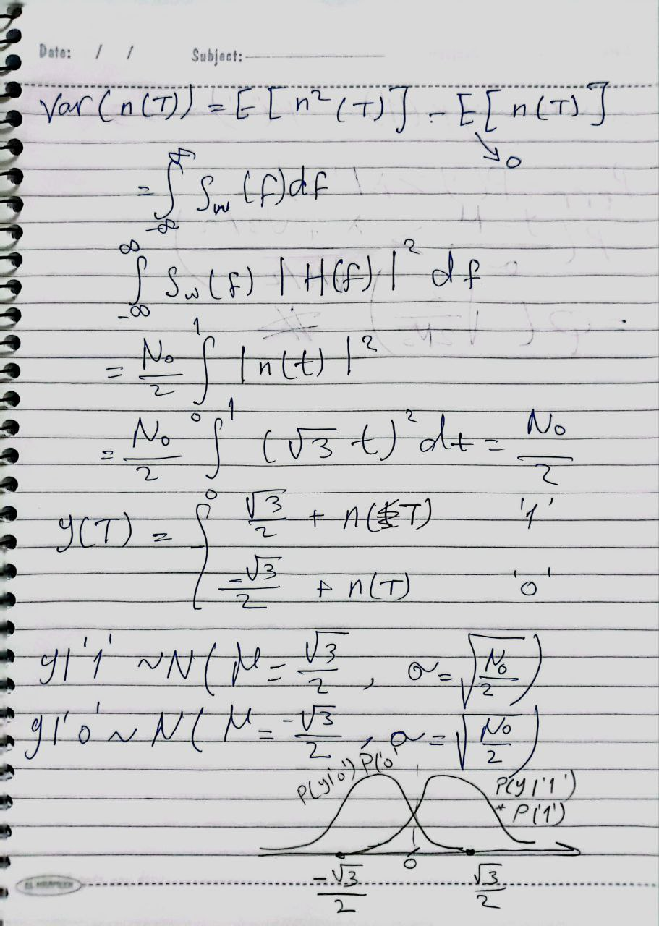

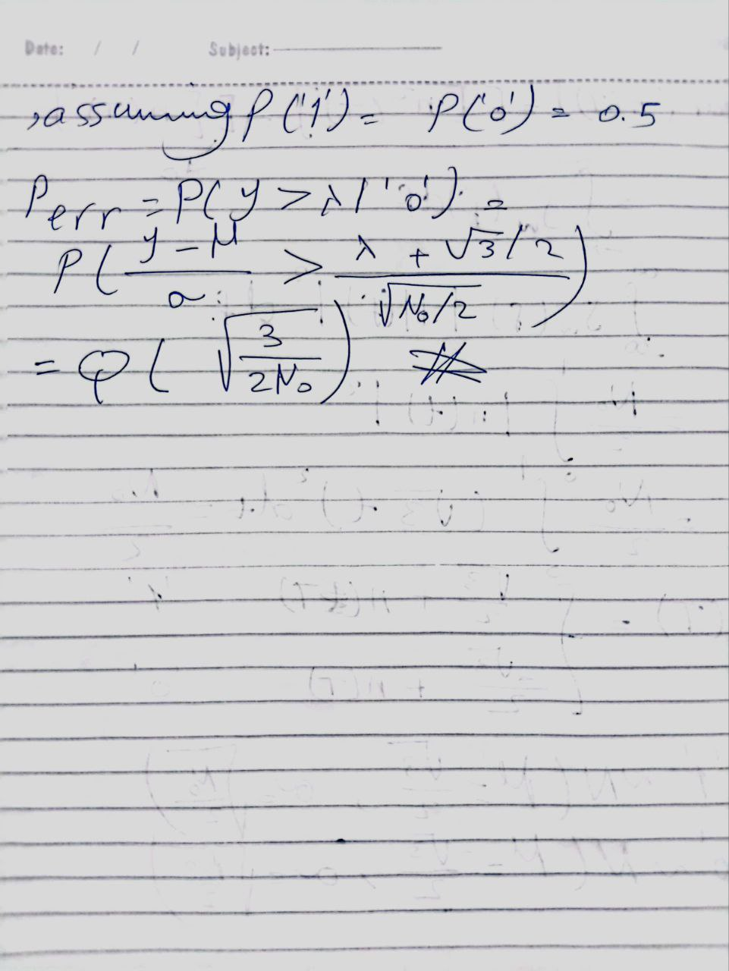

CODE

import numpy as np

import matplotlib.pyplot as plt

import scipy.special

# defining signal to noise ratio , number of bits , samples per bit

SNR, nbits, s_p_b = 10, 100, 10

# generating random_bits

random_bits = np.random.randint(2, size=nbits)

# shaping pulses

signal = np.zeros(nbits * s_p_b)

for i in range(nbits):

if random_bits[i] == 1:

signal[i * s_p_b:(i + 1) * s_p_b] = 1

else:

signal[i * s_p_b:(i + 1) * s_p_b] = -1

# Adding Gaussian noise with zero mean and variance N0/2

noisy_signal = np.copy(signal)

E = 1

No = E / (10 ** (SNR / 10))

variance = No / 2 # N0/2

for i in range(nbits):

n = np.sqrt(variance) * np.random.randn(s_p_b)

noisy_signal[i * s_p_b:(i + 1) * s_p_b] += n

# Receiver filters

# 1-The receiver filter h(t) is a matched filter with unit energy.

h1 = np.ones(s_p_b)

# 2-The receiver filter h(t) is not existent (i.e. h(t) = δ(t).

h2 = np.zeros(10)

h2[5] = 1

# 3-The receiver filter h(t) is a filter with linearly increasing amplitude.

h3 = np.zeros(s_p_b)

for i in range(1, s_p_b):

h3[i] = h3[i - 1] + np.sqrt(3) / s_p_b

# Receiver outputs

out1 = np.convolve(noisy_signal, h1)

out2 = np.convolve(noisy_signal, h2)

out3 = np.convolve(noisy_signal, h3)

# shaped pulses

plt.figure(1)

plt.plot(signal)

plt.ylabel('pure signal')

plt.show()

# noised signal

plt.figure(2)

plt.plot(noisy_signal)

plt.ylabel('signal with noise')

plt.show()

# received signal from filter1

plt.figure(3)

plt.plot(out1)

plt.ylabel('The receive filter h(t) is a matched filter with unit energy')

plt.show()

# received signal from filter2

plt.figure(4)

plt.plot(out2)

plt.ylabel('The receiver filter h(t) is not existent (i.e. h(t) = δ(t)')

plt.show()

# received signal from filter3

plt.figure(5)

plt.plot(out3)

plt.ylabel('The receiver filter has given specific h(t)')

plt.show()

sig1 = np.zeros(nbits, dtype=int)

sig2 = np.zeros(nbits, dtype=int)

sig3 = np.zeros(nbits, dtype=int)

bit_error_rate = np.zeros(3, dtype=float)

bit_error_rate_theo = np.zeros(3, dtype=float)

for i in range(nbits):

if out1[i * s_p_b] > 0:

sig1[i] = 1

else:

sig1[i] = 0

if out2[i * s_p_b] > 0:

sig2[i] = 1

else:

sig2[i] = 0

if out3[i * s_p_b] > 0:

sig3[i] = 1

else:

sig3[i] = 0

bit_error_rate[0] = bit_error_rate[0] + np.logical_xor(sig1[i], random_bits[i])

bit_error_rate[1] = bit_error_rate[1] + np.logical_xor(sig2[i], random_bits[i])

bit_error_rate[2] = bit_error_rate[2] + np.logical_xor(sig3[i], random_bits[i])

bit_error_rate = bit_error_rate/len(random_bits)

bit_error_rate_theo[0] = 0.5*(1 - scipy.special.erf(np.sqrt(2/No)))

bit_error_rate_theo[1] = 0.5*(1 - scipy.special.erf(np.sqrt(2/No)))

bit_error_rate_theo[2] = 0.5*(1 - scipy.special.erf(np.sqrt(3/(2*No))))

OUTPUTS

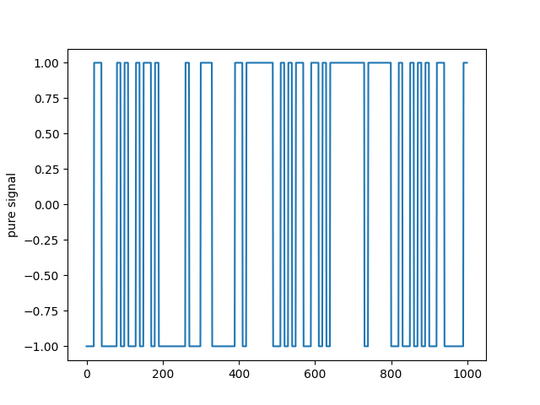

Figure1

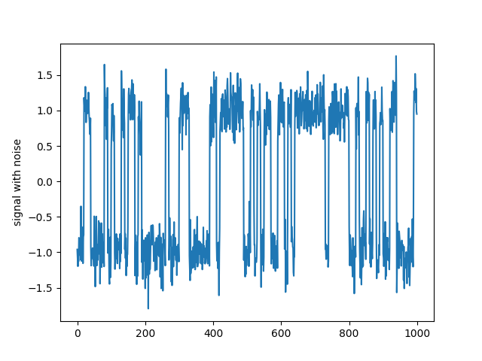

*Figure2*

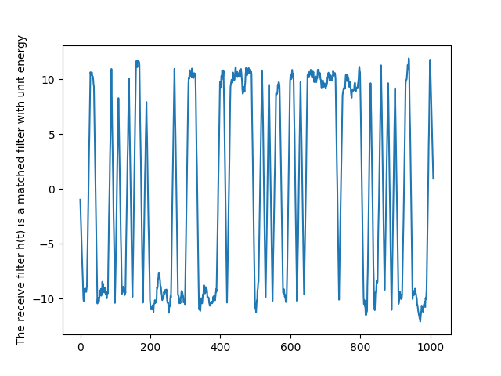

*Figure3*

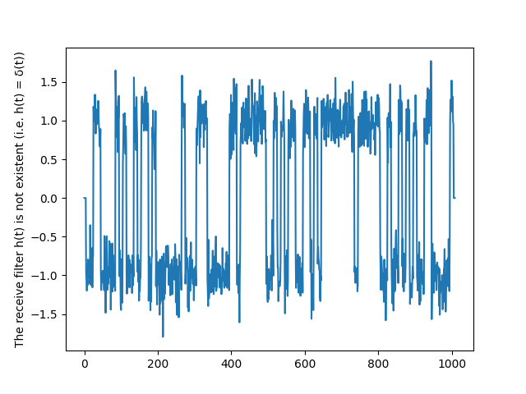

*Figure4*

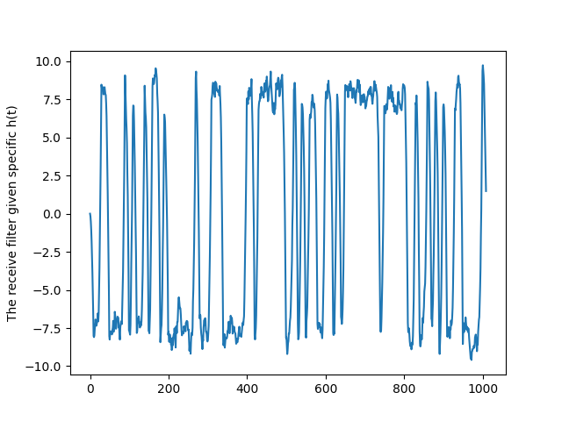

*Figure5*

5- As the signal-to-noise ratio (SNR) increases, it indicates a reduction in the noise present. As a result, the bit error rate (BER) decreases since there is less noise to disrupt the signal. This correlation between SNR and BER can be expressed as a function that decreases.

6-the second case because the noise is maximum in this case as there is no filter at all .